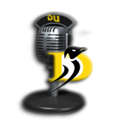

Communications Department
DU Radio Class
Melba Beals, Stuart Horne

Radio Performance Do’s and Dont’s
DO:
Pay attention to your posture
Project your voice
Maintain consistent distance from mic
Maintain consistent voice volume
Finish sentences with authority
Repeat dates, phone #’s, URL’s, email addresses, etc.
Remind listeners who you are, the name of your show and why you are on the air
Forward promote
- Whenever you take a break
- During broadcast where appropriate

DON’T:
Get distracted
Talk to anyone unless they have a mic
Talk about how you’re tired or have a headache
Complain
- opinions are okay as long as you provide a solution
- don’t mention technical difficulties
Say “you know”, “um”, “sooo”, “anyways”, etc.
Mumble
Wing it
Swear – or anything even close. NO: crap, damn, freakin’, etc.

